“Gheorghe Asachi” Technical University
Automatics and Computers Faculty
Distributed Systems and Web Technologies

Dissertation Project

Coordinator Student
Conf. dr. ing. Darie Mihai
Mihai Horia ZAHARIA Software Engineer
DSWT 1B

Iasi 2013

MViewer
Video, Audio, Remote
Conference System

Technical Documentation
Version 1.7
05/02/2013

Date | Version | Author | Comments
04/21/2013 | 1.0 | Darie Mihai | Introduction - context definition
04/22/2013 | 1.1 | Darie Mihai | Conclusions regarding the product general context
04/23/2013 | 1.2 | Darie Mihai | Area in which the project falls
04/24/2013 | 1.3 | Darie Mihai | Problem documentation - Analysis
04/28/2013 | 1.4 | Darie Mihai | Possible issues identification
04/30/2013 | 1.5 | Darie Mihai | Technical analysis, technology stack recommandation, designer’s comments, Product development technology choosing
05/01/2013 | 1.6 | Darie Mihai | Theoretical approach, Deployment Diagram and Protocol Documentation, Future Directions, User input data validation test
05/02/2013 | 1.7 | Darie Mihai | System functionality – screen captures, User interface adjustment
05/05/2013 | 1.8 | Darie Mihai | Main classes’ description, Contributions and Application

Chapter 1: Introduction
1.1. General context
1.1.1 Context definition
Most important aspects of the application context are:
- where is the end user located
- who is the end user and what other resources could be found nearby
- which of the resources nearby are affecting the execution environment
Computational environment is composed of the available processors and input/output devices that are used by the end user.
User environment is composed of the location, persons nearby and social situation.
Phisical environment is composed of the levels of luminosity and noise.
Application context is represented by any piece of information that can characterize an entity’s state and that can be considered relevant for the interraction between end users and the application, including the end users and the applications as well.
Context information can be characterized by 4 major information categories:
- the identity reffers to the ability of assigning an unique identifier to an entity into a namespace used by applications
- the location includes the orientation and size as well as other information that can define spatial relationships between common area, proximity or isolation
- the state reffers to a component that can be interrogated e.g. processor workload, the existence of some files on an operating system
- the time is an information that helps describing a situation, can indicate the validity period of some other information
Context information functions is reffering to the way of which the application is using the information:
- information and service presentation reffers to the applications that are presenting context information to the user or are helping the user to take specific actions
- automatic service execution describes applications that are triggering a command or are reconfiguring the system in the absence of the end user based on a specific context update
- supplemental information attachment to the context for using them later reffers to the applications that are labeling the data with context relevant information
1.1.2 Conclusions regarding the product general context
Regarding the computational environment, the Mviewer will use the processors that reside on the computers where the application will live and also the attached devices such as microphone and webcam (which can be embeded to the computer or stand-alone) and of course the keyboard and mouse for the remote conferences.
Regarding the user environment, the location will affect the system performance based on the quality of Internet connection and the network configuration in which the MViewer will be placed. Slow Internet connections may degradate the conference performance causing video and/or audio slowness or de-synchronization. Also the remote conference will be affected by slow Internet connections, the screen captures may pass slowly from a computer to another and the remote commands will be executed with kind of delay. Regarding the network configuration, blocked ports may prevent the end-users from being connected with eachother regardless of their world wide location. For this case it might be necessary to use the standard TCP 80 port which must be opened through the Firewall of each users’ computer. Usually, the number of persons that are using the Mviewer doesn’t affect the overall performance of the video/audio/remote conferences. The conferences can run even with only two participants.
The phisical environment must not affect the application behavior.
Further analysis on how are the information categories influencing the Mviewer behavior and performance:
- the Identity concept is used for uniquely identify each person that is using the Mviewer by an encrypted hash which can be used by the end-users by starting the conferences and transferring files
- the Location concept is affecting the Mviewer usage by the already metioned network configurations (IP addresses), Firewall and other security related rules
- the State information category is represented by the CPU and RAM memory workload which can affect the conferences performance if other applications are keeping the computer busy; other than that, the IO devices used by the Mviewer must not be used in the same time by other applications because this may lead to conflicts
- the Timing concept is affecting the application in a high percentage, referring to the synchronization that must exist between the audio and video captures but also between the screen captures and remote commands
Information and service presentation is represented by the video/audio/screen captures that are helping the viewers in taking specific actions on their end.

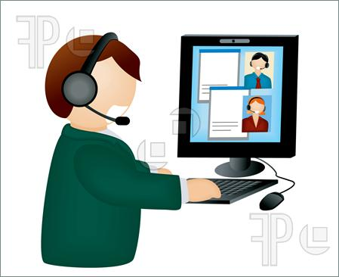
Fig. 1: Web conference illustration
The Mviewer will not use any automatic service execution because all of the conferences and commands will be provided by the end users as well as the system configuration that will not change untill the users updates it.
The Mviewer will use supplemental information attachment for the video and audio captures by labeling them with specific timestamps in order to achieve synchronization.
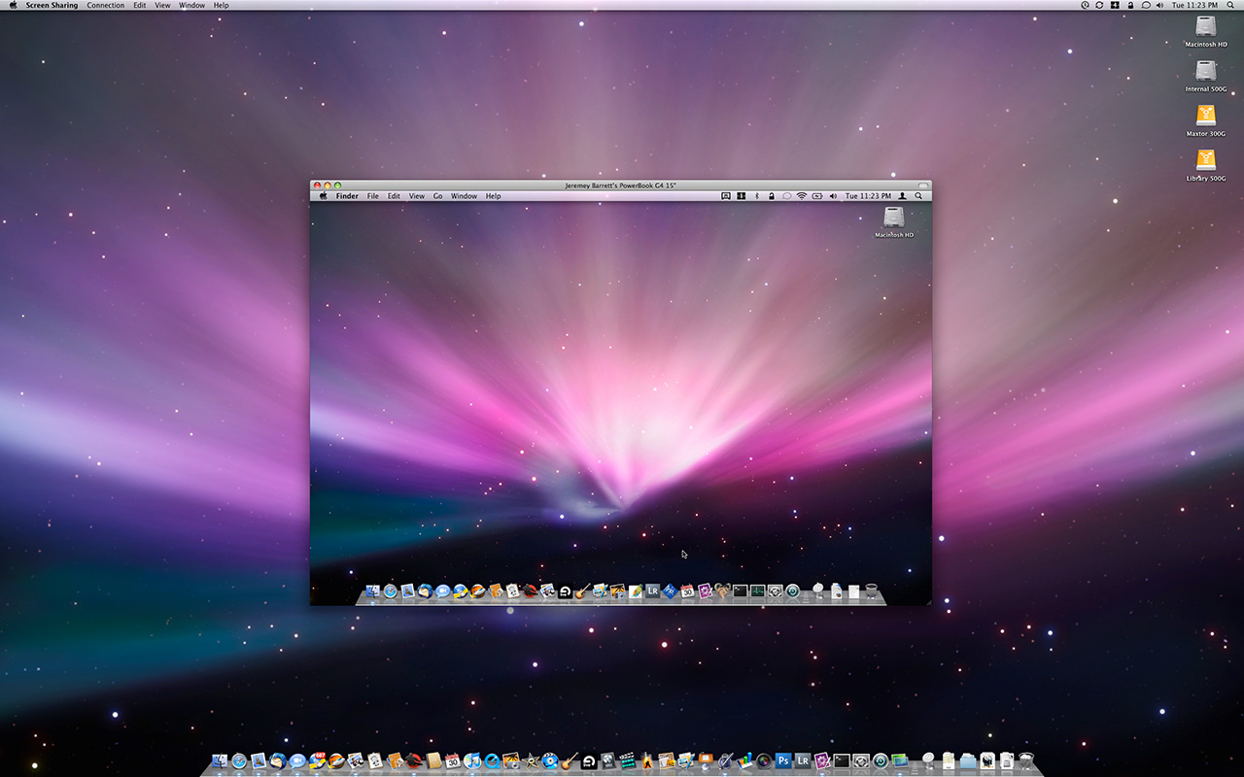
Fig. 2: Screen sharing illustration
1.2 Area in which the project falls
1.2.1 Task description
The proposed project is the development of an application for supporting remote conferences (e.g. video, audio, screen sharing).
The project result shall be the desktop application named MViewer which will give the end-users the possibility of doing video/audio conferences and remote conferences in which the presenter will share his screen and the viewer will take control of his screen.
There MViewer application will not communicate with any other existing applications on the market but will have to embed all of the above mentioned features including small size file transfer feature.
The project fits in the applications domain named „Parallel and Distributed Conference Systems”.
1.2.2 Video/Audio/Remote conference definition
An audio conference call is a phone call in which the calling party wishes to have one or more partners listen in to his audio call. The audio conference may be designed to allow the called person to participate to the call, or the conference may be setup so that only the caller may speak but there can be a specific configuration feature that can switch between the two setup options at the conference runtime.
Video conference refers to a communication over a distance between one or more participants whenever audio and video is broadcasted in near real-time. Video conferencing is held by a set of telecommunication technologies which allow the participants to communicate in a two-way video and audio transmission. The core technology used in video conferencing is digital compression of audio and video captures in real time and the components that serve the communication are video inpout/output, audio input/output, data transfer and computers.
Screen sharing conferences are possible through desktop/application sharing features where participants can view anything the presenter currently has shown on their screen. Some of the screen sharing applications allow for remote desktop control so that participants can manipulate the presenters screen by sending remote commands.
1.2.3 Product description from the domain point of view
The scopes mentined in the remote conference definition above are fully acomplished by the MViewer through it’s features.
The web conferencing refers to a service that allows conferences to be shared with people based on remote locations. Generally this type of conferences are made possible by Internet technologies, particularly on TCP/IP connections which is the case for the MViewer.
The MViewer allows real time peer to peer communication between remote locations as well as multicast conferences where a presenter is broadcasting captures to multiple recipients. Web conferences are usually used for online meetings, trainings, lectures or personal presentations that occur from any computer that is living online.
Some of the applications that are making the web conference possible require installation of additional software that has to be downloaded by both presenters and viewers. The MViewer depends on such software as well which will be detailed in the document later.
Some of the suppliers that are selling conferences software are not providing the full pack of features but the MViewer will collocate all of the video/audio/remote features in a single application.
One of the characteristics of the web conferences is the live video streaming where full motion webcam is helping the presenter in pushing captures to the audience.
Web conferencing isn’t standardized and this is generating lack of interoperability between different systems, dependence on specific platforms, high costs for developing and maintaining such systems. Usually you can take any kind of architecture and use it for implementing a conference system and also a custom specific communication protocol.
There are three deployment models used for web conferencing: hosting service, software and appliance. The MViewer falls in the software category.

Fig. 3: Web conference architecture illustration

Chapter 2: Problem documentation
2.1 Analysis
TODO: Decide if to add the waterfall model specification
2.1.1 User needs identification, project ideea, project goals
The project main idea is to design a system that would facilitate the end-user in holding remote conferences based on screen sharing and remote command processing. To take advantage of the system, there must be at least 2 end-users involved in the remote conferences.
Beside the remote conference feature, the system must provide the end-users with video and audio conference support as well as small size file transfer feature.
The start-up feature of the application should be the contact list definition, otherwise the other features may be impossible to use.
These are the main features that the application must provide, the other features will be their basis.
2.1.2 Detailed system description (main activities and their basis)
The category of features on which the main application features are depening includes the System Configuration module which consists of the following application specific configurations:
- friendly name specification, which will be displaying at the partner’s contact list
- language selection (localization), whether it is English or Romanian
- video captures broadcasting interval
- audio captures broadcasting interval
- remote captures broadcasting interval
- public IP and port configuration
The following actions reside in the above mentioned category as well:
- starting a specific conference by using the control panel after selecting a specific contact from the list
- pausing and resuming conferences after focusing on the conference form and using the control panel
- stopping a specific conference by using the control panel and selecting either a contact from the list or focusing their conference form
- reviewing conference status for each of the contacts by clicking on their list entry
The 3rd category of application features is represented by the features that depend on the main application features and on the 2nd category of features mentioned above. This category includes:
- watching the video captures sent by the partner and optionally send yours (this can be achieved through the pause feature which will hold only one direction of capture broadcasting)
- listening to the audio captures sent by the partner and optionally send your (achieved in the same manner as pausing the video conference)
- viewing the screen captures sent by the partner and optionally sending mouse or keyboard remote commands that should be processed at the partner’s computer
- locally saving the files sent by the partner for later review
2.1.3 Project phases identification and time planning
TODO: create project plan using Microsoft tool
2.1.4 Resource estimation and specification
The human resources involved in the project development will be the student - Darie Mihai - which is the executive and the coordinator - project manager Mr. Zaharia.
The physical resources shall be the student’s home desk, the coordinator bureau which will organize the project status check conferences, the student’s personal computer and a bunch of computers from the Faculty on which the system will be implemented and tested and an Internet connection which will facilitate the project research and data transfers.
2.1.5 Risk analysis
One way of ensuring that you accomplish best security properties is to employ threat modeling using STRIDE which is an approach proposed by Microsoft, standing for Spoofing, Tampering, Repudication, Information Disclosure, Denial of Service and Elevation of Privilege.
Below you may find a table that maps threats to security proprieties:
Threat | Security Property
Spoofing | Authentication
Tampering | Integrity
Repudiation | Non-repudiation
Information disclosure | Confidentiality
Denial of service | Availability
Elevation of privilege | Authorization
For following up the STRIDE principles we must descompose the system into relevant components and analyze each of them for susceptibility to threats and mitigate them.
In the below diagram you may see which threat could affect specific elements of a system.
Element | Spoofing | Tampering | Repudiation | Information Disclosure | Denial of Service | Elevation of Privilege
Data Flows |  | X |  | X | X
Data Stores |  | X |  | X | X
Processes | X | X | X | X | X | X
Interactors | X |  | X

2.1.6 Possible issues identification and resolution suggestions
Data Flows Analysis
Tampering: The data in transit may not be modified by 3rd parties that don’t have client and server certificates installed because their requets would be rejected by the MViewer when receiving requests that have unidentified senders.
Information Disclosure: Data in transit during the web conferences may be read by attackers by intercepting the traffic done between 2 MViewer applications because they are not encrypting the exchanged data.
Denial of Service: The system may be a victim of denial of service in case if somebody finds out the key used in generating the encrypted user identities. This may lead to discovering the IP:Port pair and will turn out in server overwhelming by making multiple requests to it (i.e. Ping commands) causing the service to be unacesible by other clients. In a secured network the deniel of service can be prevented by tracking the amount of traffic done by the service consumers and create a firewall blacklist of those who are suspected that are causing the denial of service.
Data Stores Analysis
Tampering: The information retained in the contacts database may not be modified remotely by 3rd parties that don’t have client and server certificates installed because their requests would be rejected by the MViewer. The contacts database file can be manually editted by anyone as it has a simple XML file format so we’re exposed to tampering.
Information Disclosure: The database XML file is not encrypted so it can be read and understood by any human being and here comes the information disclosure.
Denial of Service: Basically the data store access mechanism cannot be overwhelmed by attackers because all the requests must pass through the business module that is rejecting requests that are coming from unauthorized clients (by checking their certificates).
Processes Analysis
Spoofing: The processes that take place within the web conferences are exposed to spoofing because an attacker can pick a tripple DES encrypted identity from one of the participants and start sending commands through the conferences claiming that he is someone else. Basically this is possible only if the attacker comes from inside the web conference and has client and server certificates installed, otherwise the system will reject his requests.
Tampering: The attacker can tamper the data within a process and may corrupt the memory and by this way he may prevent the video module from accessing the web camera and he may remove the web captures from the buffer. This results to a denial of service.
Repudiation: This threat can appear if the attacker is sending harmful commands through the remote command feature involved in screen sharing conferences and he might not admit that he done the harm on the partners’ computer.
Information Disclosure: Usually we may think of this type of attack to be related more to the data flows but it can affect the processes that hold data in the RAM memory as well. The attacker can break into the memory used by a process and steal screen shots information and after that he can conduct other attacks by using the remote command invocation feature.
Denial of Service: If spoofing has effect and the attacker picks up the 3DES identity of someone else, he can remove the spoofed person from the others contact list and by this way the attacker denies the service at both end-user sides preventing their communication.
Elevation of privilege: An attacker may use the client-server buffer (if it is too large) to execute his own code within the application.
Interactors Analysis
Spoofing and Repudiation can affect both of the presenters and the viewers that take part to a conference because of the threats described above.
2.1.7 Technical analysis, technology stack recommandation, designer’s comments
Recommendations for the MViewer application:
- similar applications that are already on the market must be studied
- they must be compared with eachother and after that the designer must comprise all main features dicovered with additional enhachments or new features
- the application must give permanent feedback to the end-user, information display in the graphical user interface must be updated accordingly when a contact status has changed or during the web conferences while captures are exchanged between multiple MViewer instances
- the developer must use C# as development technology because it is an elegant, simple, type-safe, object-oriented language that allows the programmers to build a large spread of application types; it’s a high level development language that has a wide set of libraries that are facilitating the implementation of any requirements through the easy access to the operating system resources, easy way of drawing graphical interfaces and addition of control event callbacks
- the developer must study or generate his own web conferencing protocols
- MVC design pattern in combination with the 3-tier architecture must be studied and applied because these two patterns are bringing up on oane hand easy coupling between the front end and back end and secured access to the database in the other hand
- other design patterns must be studied and applied because they are usually built for solving particular problems
- the system settings must be saved into an XML file that can be easy modified by system administrators directly; by this way we are keeping the MViewer independant by SQL Server or other database management software that had to be installed before starting web conferences
2.2 Comparison of similar existent products from the same category
TODO
2.3 Product development technology choosing
As already mentioned, C# provides easy access to the operating system resources which will be the core basis for all the modules of the MViewer. Other than that, after doing the research I noticed the following strengths of the C# against other programming languages:
- C# has native garbage-collection which is triggered once an object is out of use (although, it is recommended that the garbage collector should be triggered specifically when the programmer knows that an object is unused, usually in the finally block)
- it has a huge standard library with a lot of usefull stuff that is already and well-implemented and easy to use, you don’t have to implement lots of features from scratch
- you can define objects, methods and fields that can be accessed only within a specific assembly where they are declared but not from other assemblies, this methodology is known as internal objects
- instead of private static class implementations you will use elegant and friendly native constructs such as Properties and Events
- C# has Lambda expressions and LINQ that are used for queries
- C# framework is automatically allocating memory for objects by using the „new” operator
- C# is deeply integrated with Windows, the targeted operating system for MViewer
- C# supports native resource-management by using the „using” statement which is automatically allocating and de-allocating the memory for objects
- derived class constructor can call the base class constructor by using the „base” statement
- when a virtual method is called in a constructor, the used method is the method implemented by the most derived class
- the exceptions are described in full detail, including inner exceptions and strack trace
- you don’t need to use header files in C#
- unassigned objects may not be used because C# is raising compilation errors
Chapter 3: Theoretical approach
3.1 Characteristics and features analysis from the Use Case Diagram
The use case model is described by using one or more use case diagrams. This type of diagram contains the following modeling elements: actors, use cases and different relationships between the elements that are: generalization, association, dependency.
3.1.1 Actors and Use Cases - definitions and identification
An actor could be anything or anybody that may interact with the MViewer system by sending or receiving messages to/from it or that can exchange information with the MViewer.
Actor types:
- primary actors: the ones that are using the systems’ main functionality - they are the end-users that are initiating web conferences, sending their video/audio/remote captures and are looking at their partners’ captures as well, which are also primary actors; the primary actors may also do small file exchange
- secondary actors: the ones that are using the system’s secondary functionality - this is the system administrator that is using the configuration module to keep the application up and running
- active actors: they are initiating the use cases
- passive actors: they are taking part only at one or few use cases
For defining the entities that are interested in using the MViewer system we must answer the following questions.
Who is going to use the system’s main functionality? - the primary actors
The primary actors may be segmented in 3 categories: actors that are using the video conference feature, actors that are using audio conference feature, actors that are using the screen sharing conference feature. These primary actors are active in the same time.
Who is going to need the system during the day by day work ? same answer as above.
Who is going to administer and maintain the system ?
This duty will be assigned to a system administrator that will be a secondary actor.
What hardware units will make use of the MViewer system?
Considering that the project is a software application, the dependency is in the other way: software depends on hardware.
With what other systems (computers or applications) may the MViewer interact ?
Regarding the applications, we can consider the operating system and the drivers used to communicate with the hardware components: computer resoruces and devices (video/audio).
Who is the final gainer that will take advantage of the system’s results?
The final gainer is one of the primary actors that will watch the video/audio/remote conference captures.
An use case can be defined as a system’s complete functionality in the way that is perceived by the actor. In UML (Unified Modeling Language) it’s defined as: a sequence of actions done by the system so that it can provide value to a particular actor. The actions may involve communication with a number of actors (that can be end-users or other systems) or they may involve internal system processing.
An use case is a class not a single instance of it. The class describes the functionality as a whole, including possible alternatives, errors and exceptions that may appear during the application runtime. An use case instance is known as scenario and it represents an actual use of the system.
The use cases are connected to the actors through associations, named also communication associations. Usually, these are one-on-one undirected relationships which means that an actor instance is communicating with an use case instance and the communication is bilateral.
The process of use case identification stars from the already identified actors, for each of the actors we will be asking the following questions:
What are the systems’ expected features by the actor? What should an actor be able to do?
The primary-active actor (who want’s to do web conferencing) is expecting to be able define his own contact list, initiate web conferences and control their flow, sometimes he may want to do a file exchange with his partners. All of these features imply the systems’ capture exchange functionality.
The secondary-active actor that is the system administrator is expecting that the MViewer should expose a configuration form used for setting the system parameters which will affect the system runtime behavior. This actor also expects to have a log file for his review if some particular system feature isn’t working properly.
Is the actor going to need to read, create, modify, store or delete specific information from the system?
Both the primary and secondary actors will need to create, store, read, modify or delete information from the MViewer storage system as follows:
- the primary actor will create and store the contact list that can be modified or completely removed from the storage
- the secondary actor will create a system configuration file that will be stored and updated when the MViewer is moved from a computer to another
Is the actor going to know about any event triggered in the system? What feature is represented by these events?
The primary-active actor must be aware when someone requests his contact, initiates web conferences or removes him from his contacts list. The features represented by those types of events are the video/audio/remote conferences functionalities.
Is the actor able to simplify his daily work or to work efficiently by using the systems’ new features?
The primary-active actor especially is the one who benifits of the MViewer’s new features described in Chapter 2.2.
Other questions that do not imply any actual actor:
What kind of input/output is needed inside the system? From where are they coming and where are they going at?
The input data is represented by the system configuration parameters that are inputted by the system administrator. Other input data is represented by the contact person details inputted by the primary-active actor for defining contacts lists.
The output data is represented by the video/audio/remote captures that are captured by the system and sent to the primary-active actors conference partners.
3.1.2 Use Cases description
Use Case description is done by a text that contains a simple but consistent specification of the way in which the actors are interacting with the systems’ use cases. The description will catch the system behavior and it will ignore the details used in implementing the systems’ features.
Figure #1 from Chapter 3.2.4 of the Software Requirements Specification document describes the process of configuration and web conference initialization between two MViewer application instances.
First step for using the MViewer is the application start and configuration that has to be done by the secondary-active actor that is the system administrator. This step must involve 2 different MViewer application instances so that web conferences can be started later.
The second step before starting any web conference involves each of the primary-active actors of the MViewer instances that must create a contact list and add new people in it. This use can take place after 2 persons exchanged the automatically generated identity string from the MViewer graphical interface.
Once a contact list created and both MViewer instances are kept online, the actor may proceed to the 3rd use case that is the conference initiation. They may choose one of the video/audio/remote conferences or all of them and send a request to their partner. If the partner provides a favorable response the web conference may start and both end-users are participating according to their role (they may send video/audio/screen captures or they can execute remote commands).
The 4th use case may be the file transfer initialization that can be done by one of the end-users, of course, if the partner accepts his request. At the end of the use case the file receiver may review the document.

Chapter 4: Used methods
4.1 Design and implementation
4.1.1 UML diagrams and conference protocol description
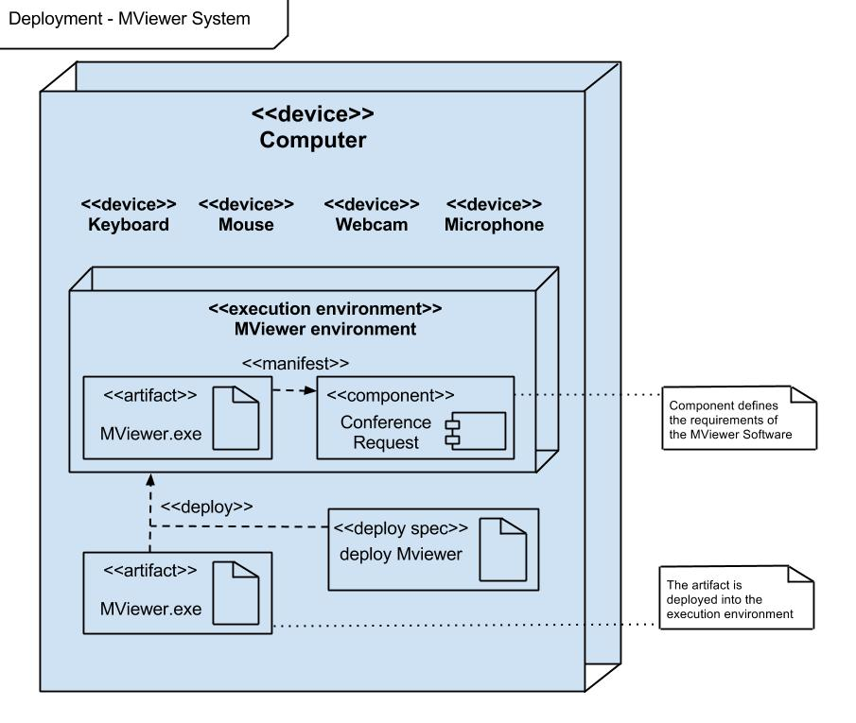
Fig. : UML Deployment Diagram
The MViewer application will have a distributed structure based on the 3-tier architecture which will be comprised of the View, Business and Data Access modules.
For communication, two instances of the MViewer will use Windows Communication Foundation server and client modules. The web conference initiator will use his WCF Client to push captures to the partners’ WCF Server.
The MViewer application resources will be packet into a .zip archive and will be deployed onto each end-user’s computer station. It will take advantage of the computer resources specified in the Deployment Diagram above. Finally, the end-user will open the MViewer.exe file for starting the web conferences.
The contacts list will live at the root directory of each MViewer instance and will be kept in an XML file format.
There will not be any central server that would facilitate the communication between two instances of the MViewer. The MViewer itself will have embeded the WCF client and server modules which will permit the data exchange between several computers used by the primary-active actors.
There’s a custom protocol used by two MViewer applications in exchanging information that is described in the sequence diagram from the SRS document.
4.1.2 Conference protocol documentation
The protocol is using the same pattern for all conferences types (video/audio/remote/file transfer).
Each conference is starting with a conference request sent by the initiator to his partner.
The initiator is identified at the partners’ end through his Identity String generated with Tripple DES encryption of his IP:Port pair using a key embeded in the MViewer application code (this key will never be changed as nobody has access to it).
If the partner accepts the request after he is notified through a Message Box, the conference may start first with the initiator captures that are sent to the partner.
From the other side, the partners’ MViewer application will automatically start it’s own conferencing modules so that it can respond to the conference initiator with his own video/audio captures.
The remoting conference will work only in one direction, that is: screen captures are sent from the initiator to the partner which will respond with remote mouse and/or keyboard commands that will be processed at the initiator’s computer by his MViewer application.
The file transfer will go through only if the partner has accepted the transfer request after reviewing the file exchange details (name, size, sender friendly name).
If the conferences request is denied by the receiver, the initiator will be notified of the partners’ conference deny in the main MViewer form by using a label.
4.1.3 Main classes’ description
This chapter will start with the presentation of the classes that are implementing the Model - View - Controller pattern which is the core of the MViewer application.
The Model.cs class is implementing the interface that you may see in the below figure:

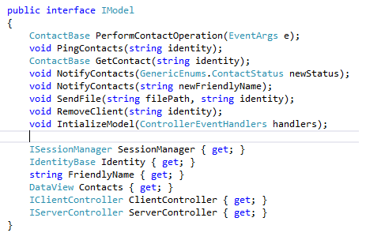
Fig. : Model interface - methods signatures
As it can be observed, the Model initialization is done into internal class methods that are not disclosing the implementation. They are called only from the Controller module.
The model instance is shared by both the Controller and the View. The first one is triggering commands implemented by the Model when it receives them from the View module. But in the other hand, the View has the right to update itself by pulling up the data from the Model that is the Contacts DataView as exposed as property by the Model interface. This is the basic principle of the MVC pattern.
Each command that is triggered by the end-user goes from the View module through the Controller which is forwarding it to the Model which will execute it.
The View.cs class is implementing the interface that you may see in the below figure:

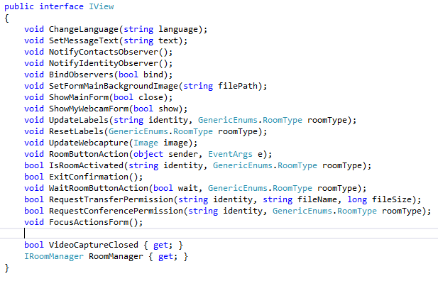
Fig. : View interface - methods signatures
The View module is basically helping the application UI to communicate with the Model module that keeps up the data. The commands such as mouse button clicks performed by the end-users are being sent by the View module to the Controller module by triggering specific events and the Controller is processing and marshalling them to the Model module where necessary. If the Model changed some specific information at its end, the controller is notifying the View which is updating itself directly from the Model module.
The Controller module is composed of 4 partial classes - MainController.cs, AudioController.cs, VideoController.cs, RemotingController.cs, FileTransferController.cs - that are implementing the interface that you may see in the below figure:
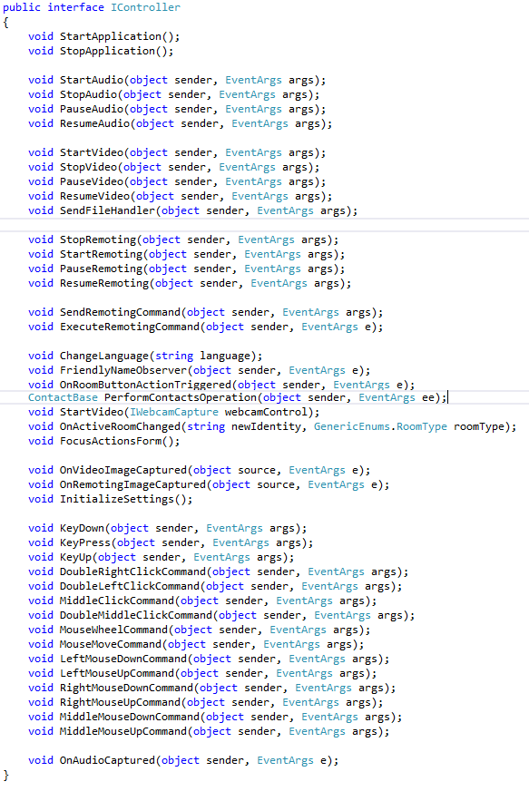
Fig. : Controller interface - methods signatures
As already mentioned, every action that the MViewer will take should go through the Controller that will process it. The Controller module is splitted into 4 classes having their own specific. They usually implement operations such as conference initialization or shut down and the file transfer operations.
Conference room commands are addressed through room type and command type.
There are 4 types of rooms video/audio/remote/transfer which are handled by the following classes - VideoCommands.cs, AudioCommands.cs, RemotingCommands.cs and TransferCommands.cs - which are containing the operation specific delegates. The delegates can contain one of the following operation types: start/stop and pause/resume for video/audio/remote conferences.
TODO

4.2 System functionality – screen captures
Below you may see a sequence of screen shots based on the application usage steps.
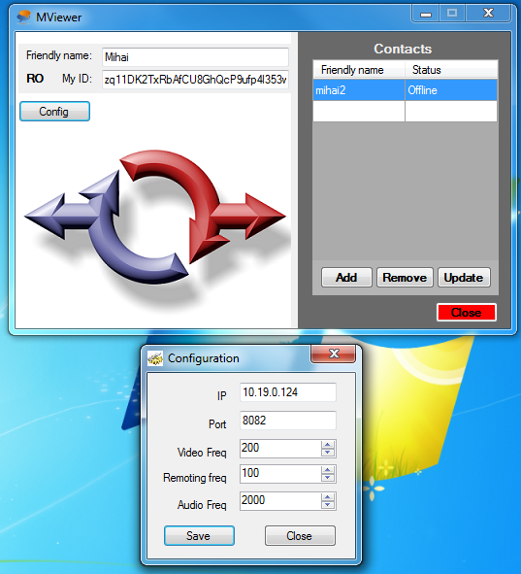
Fig. : System configuration form
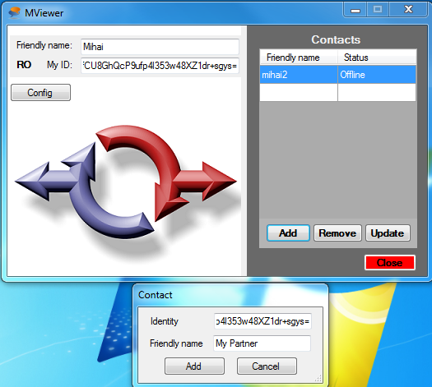
Fig. : Contact addition form
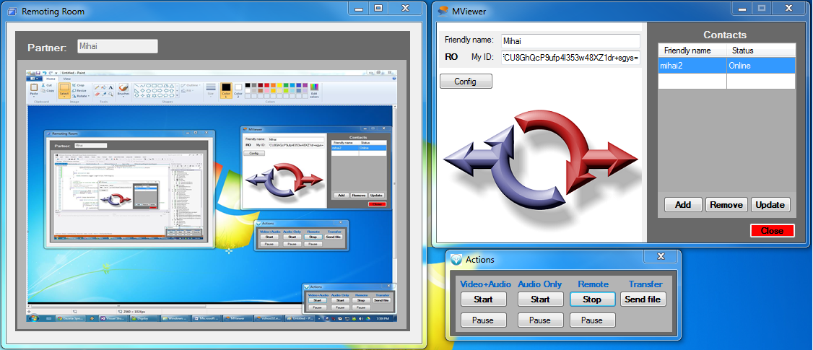
Fig. : Remote conference - screen sharing

Chapter 5: Obtained results and their analysis
5.1 Overall code stability test for repeated or simultaneous execution on all major targeted systems
TODO

5.2 User input data validation test
The single piece of user input that can be validated by the MViewer is the port that can be edited in the configuration form by the system administrator. Below is a sample of invalid input and the warning message that the MViewer is displaying when clicking the Save button.
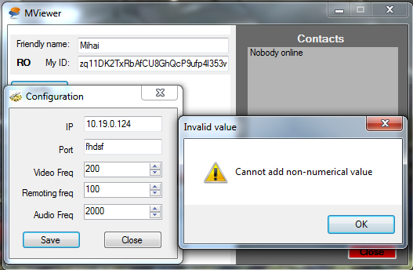
Fig. : User input validation
Other user input such as video/audio/remote captures intervals is automatically validated by the configuration form because of using the Number Drop Down control from the .NET Framework.
5.3 Average resource load by time
TODO

5.4 Verification of application behavior repeatability for same context
TODO

5.5 Simple and complex test combinations which explore various features execution
TODO

5.6 User interface adjustment related to graphical density of host operating system
Below you may see two screen shots done on the same computer before and after changing the resolution.
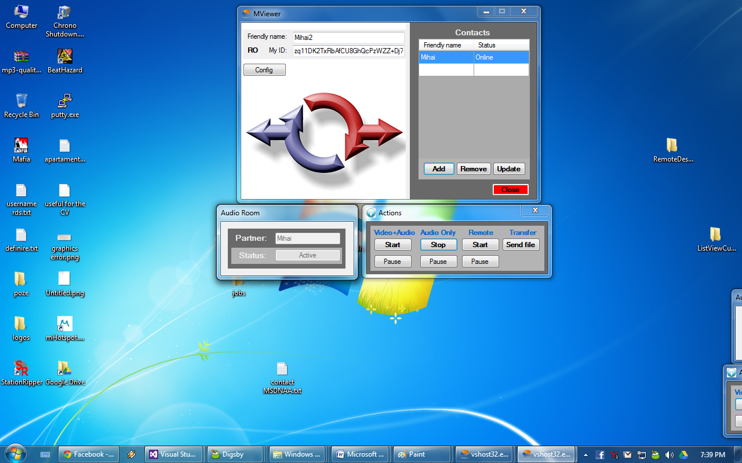
Fig. : 15 inches display on Asus Laptop 1280 x 800 resolution
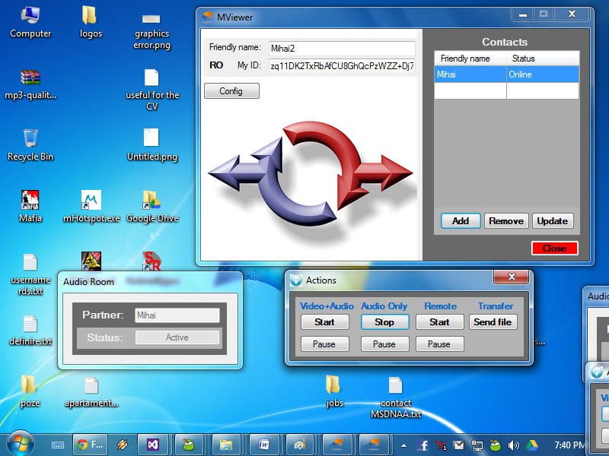
Fig. : 15 inches display on Asus Laptop 800 x 600 resolution
The application forms are being correctly displayed on both high and low resolutions that may vary from a computer to another.

Chapter 6: Discussions and conclusions
6.1Contributions and application
The objectives specified in Chapter 2 have been fully accomplished. The final product has all mentioned features implemented.
The project implementation contribution is strictly mine; there was no development team beside me and the project manager - Mr. Zaharia.
The classes that were token from the Internet have been customized according to the project needs and they have minimal impact on the project outcome. Unnecessary parts have been also removed by keeping only the needed parts of code for achieving the project objectives.
The following classes were token from the Internet and updated according to the features that they are affecting:
- 3DES Cryptography - used for generating the user identities by encryptying/decrypting IP:Port pairs;
- InputSimulator library - some of it’s classes were removed, but most of them were kept because of the microsoft windows API specifications (you cannot remove the classes even if you’re not using all of them); the used functionality from this library was the keyboard input simulator; the mouse simulator has been entirely implemented by me
- ScreenCapture.cs and ScreenCaptureBase.cs are inspired from Bob Cravens’s article regarding the multiple desktop viewer application in C#
- CommandHookMonitor library - the library is used to catch keyboard or mouse inputs from the operating system; it was modified so that the hook can run for Windows XP as well
Possible applications of the implemented product may be video and audio, audio only and screen sharing with remote control conferences that can be done in the University environment for remote lessons or inside private networks between a slight number of partners that may want to do a presentation. The product may be also used only for exchanging small size files between people.

6.2 Future directions
The following features of the MViewer can be optimized and/or extended:
- the contacts list database can be kept on a central server so that the contact addition requests can be stored on this server if the requested person isn’t online when the contact request is done
- a feature for sign in / sign out could be added to the application so that it doesn’t need to be completely closed when an user wants to go offline
- update the minimizing procedure to send the application icon to the system tray and remove all icons from the task bar
- add a configuration feature that could add proxy servers that could be used for the communication between two instances of the MViewer
- add a contact history log to the application to pull up information from the central server regarding a particular contact
- add a conference history log to the application to pull up information from the central server regarding the past conferences done between particular contacts
- add a recording option to each conference type and give the possibility of saving the recording to the end-users
- update the data transfer process with data encryption so that the system can be less exposed to attacks

